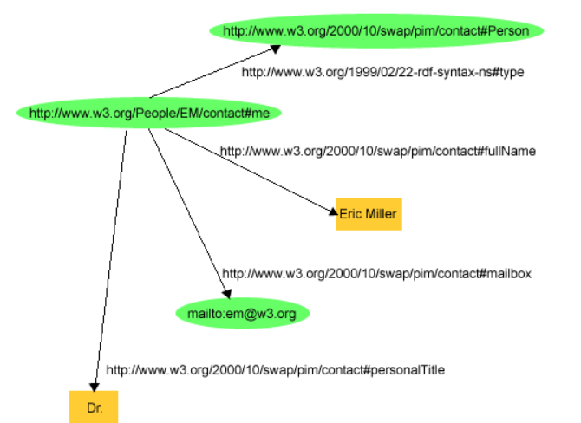

<?xml version="1.0" encoding="utf-8"?>

**<rdf:RDF** xmlns:contact=<http://www.w3.org/2000/10/swap/pim/contact#>

xmlns:rdf="http://www.w3.org/1999/02/22-rdf-syntax-ns#"**>**

**<rdf:Description** rdf:about="http://www.w3.org/People/EM/contact#me"**>**

**<contact:fullName>**Eric Miller**</contact:fullName>**

**</rdf:Description>**

**<rdf:Description** rdf:about="http://www.w3.org/People/EM/contact#me"**>**

**<contact:mailbox** rdf:resource="mailto:e.miller123(at)example"**/>**

**</rdf:Description>**

**<rdf:Description** rdf:about="http://www.w3.org/People/EM/contact#me"**>**

**<contact:personalTitle>**Dr.**</contact:personalTitle>**

**</rdf:Description>**

**<rdf:Description** rdf:about="http://www.w3.org/People/EM/contact#me"**>**

**<rdf:type** rdf:resource="http://www.w3.org/2000/10/swap/pim/contact#Person"**/>**

**</rdf:Description>**

**</rdf:RDF>**

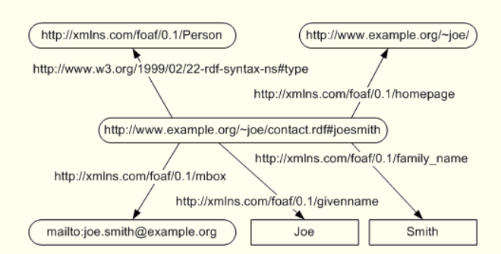

<rdf:RDF

xmlns:rdf="http://www.w3.org/1999/02/22-rdf-syntax-ns#"

xmlns:foaf="http://xmlns.com/foaf/0.1/">

<foaf:Person rdf:about=

"http://www.example.org/~joe/contact.rdf#joesmith">

<foaf:mbox rdf:resource="mailto:joe.smith@example.org"/>

<foaf:homepage

rdf:resource="http://www.example.org/~joe/"/>

<foaf:family_name>Smith</foaf:family_name>

<foaf:givenname>Joe</foaf:givenname>

</foaf:Person>

</rdf:RDF>